**Plan**

1. How to decipher OBI
2. The Earliest Chinese Handbook: an evidence of shamanic code for Gospels (Ancient/precursor)
3. The One in OBI: an evidence of shamanic code for Jesus the Savior
4. The Purpose of OBI: divination, oracle, shamanic spell or prayer

Optical illusion

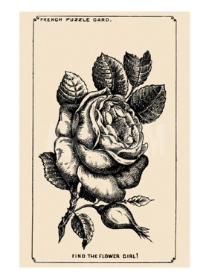

the Girl’s face hidden in the Rose

<https://www.jagranjosh.com/general-knowledge/1880s-optical-illusion-to-test-your-brain-can-you-spot-girls-face-hidden-in-rose-1661513162-1>

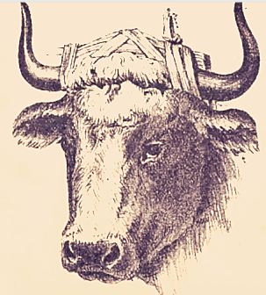

Bull Master’s Hidden Face

<https://www.jagranjosh.com/general-knowledge/optical-illusion-iq-test-only-a-genius-can-spot-bull-masters-hidden-face-1662461885-1>

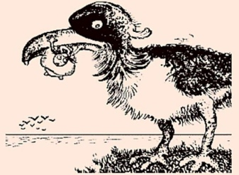

a Man catching Fish inside Giant Bird

<https://www.jagranjosh.com/general-knowledge/century-old-optical-illusion-people-with-high-iq-can-spot-man-catching-fish-inside-giant-bird-1662719345-1>

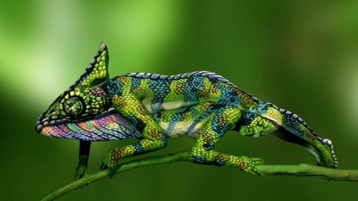

Find Two Hidden Women in 9 seconds

<https://www.jagranjosh.com/general-knowledge/can-you-spot-the-two-hidden-women-in-this-optical-illusion-within-9-seconds-1661524548-1>

 Circus Master’s Elephant Hidden in Picture

<https://www.jagranjosh.com/general-knowledge/iq-test-optical-illusion-can-you-spot-circus-masters-elephant-hidden-in-picture-1662374911-1>

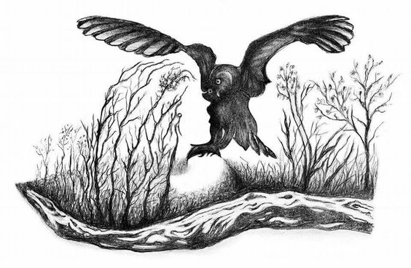

Optical Illusion for IQ Test: Spot hidden face of a Beautiful Woman inside forest with an Owl in 7 Secs!

<https://www.jagranjosh.com/general-knowledge/optical-illusion-iq-test-spot-hidden-face-of-beautiful-women-inside-forest-with-owl-1663670848-1>

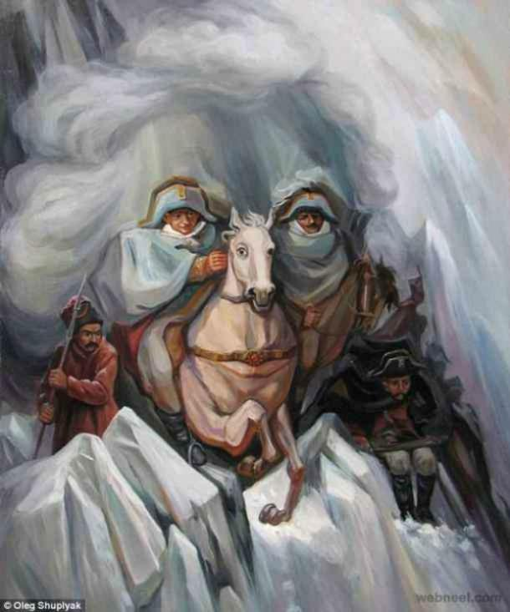

What you see first reveals your secret fear in Romantic Relationship

<https://www.jagranjosh.com/general-knowledge/optical-illusion-love-test-what-you-see-first-reveals-your-secret-fear-in-romantic-relationship-1663339314-1>

**Optical Illusion to Test Your Love Life:**An optical illusion is a mind-bending illustration of an object or a drawing or a picture that has different appearances and can be perceived differently. There are many types of optical illusions like physical, physiological, and cognitive illusions. These optical illusions are sometimes also helpful in testing helpful as our innermost desires and things we don’t usually reveal about ourselves. These are also a part of the field of psychoanalysis as they throw some light on your personality traits. Many optical illusion images can reveal hidden aspects of our personality and our deepest desires based on what we see.  One such fine illustration can be seen in an old optical illusion painting created by artist Oleg Shupliak.

## **What do you see first in this Optical Illusion?**

This optical illusion is kind of a personality test that helps in revealing your secret fear in love. The faces that you can see in this optical illusion are:

1. **A Woman** **- Fear of Losing Sleep in Love**
2. **The Mounted Soldiers** **- Fear to keep up the Appearances in Love**
3. **A Horse** **- Fear of Rejection in Love**
4. **The Soldiers in the Background** **- Fear of Playing Games in Love**

Visual Thinking Logically

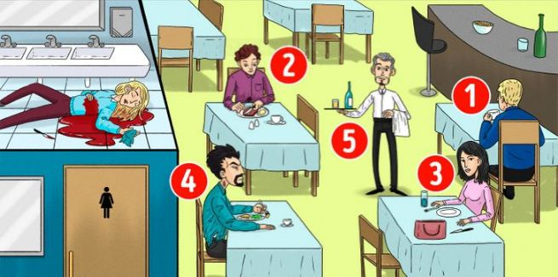

who is the Killer of the woman in the restaurant

<https://www.jagranjosh.com/general-knowledge/brain-teaser-iq-test-who-is-the-killer-of-woman-in-restaurant-picture-1662977945-1>

This IQ test is a fun way to know your Intelligence Quotient.

This brain teaser will help in testing your intelligence level based on the decision you make while looking at the problem. While solving these brain teasers, you need to scan the problem and arrive at the answer by using analytical reasoning skills. Brain puzzles make a simple riddle more interesting, as these fun games are solved with creative thinking. You need to think a little differently for coming on to the solution as the answer won’t be right in front of you. So, we have come up with an interesting brain teaser where you have to identify the Killer among the five people suspected to be the murderer of the woman in the restaurant in the image.

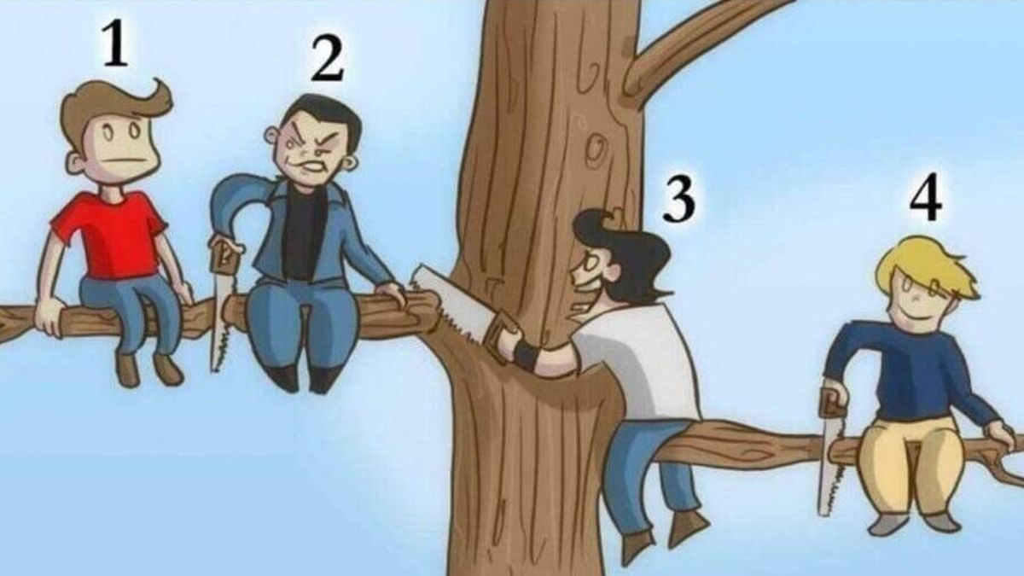

<https://www.jagranjosh.com/general-knowledge/brain-teaser-iq-test-who-is-the-most-stupid-person-in-picture-1662446335-1>

This brain teaser will help in testing your intelligence level based on the decision you make while looking at the problem. This IQ test is also a fun way to know your Intelligence Quotient. Brain puzzles make a simple riddle more interesting, as these fun games are solved with creative thinking. While solving these brain teasers, you need to scan the problem and arrive at the answer by using analytical reasoning skills. You need to use a little different approach for coming on to the solution as the answer won’t be right in front of you. So, we have come up with an interesting brain teaser where you have to identify the most stupid person among the four people sitting on a tree branch in the image.

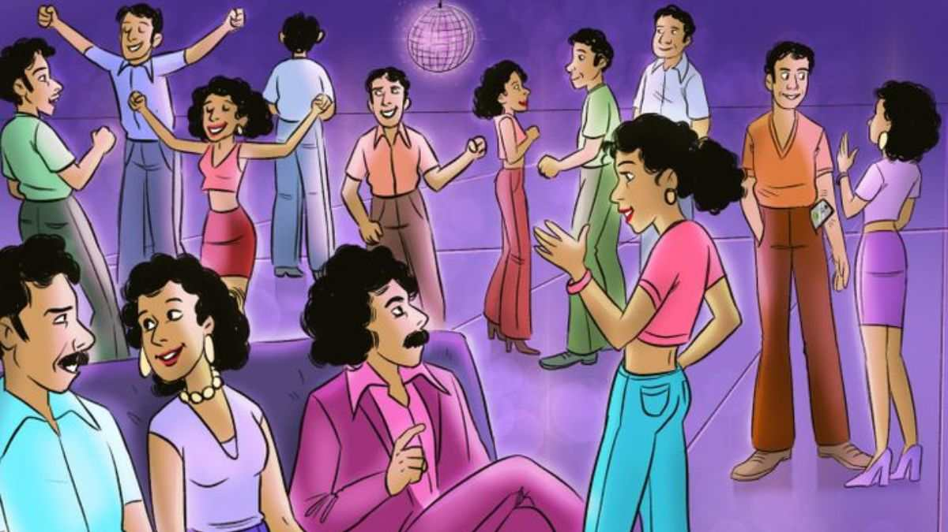

Identify who is from future in 1970s picture

<https://www.jagranjosh.com/general-knowledge/brain-teaser-iq-test-identify-who-is-from-future-in-1970s-picture-1663328461-1>

This IQ test is a fun way to check your Intelligence Level. Some brain teasers will help in assessing your intelligence level based on the decision you make while looking at the problem. The important task in these puzzles is to scan the problem quickly and arrive at the answer by using your logical reasoning skills. Brain teasers make a simple puzzle more interesting, as these fun IQ Tests are solved with creative thinking. You need to out of the box for coming on to the solution as the answer would be hiding somewhere in the picture. So, we have come up with an interesting brain teaser where you have to identify in who is from the future in the 1970s image.



https://www.jagranjosh.com/general-knowledge/optical-illusion-can-you-find-the-giraffe-in-the-forest-within-7-seconds-1671026619-1

**Optical Illusion Test:**Optical illusions are mind-bending images that challenge your perception and test your observation skills. There are three types of optical illusions literal, physiological, and cognitive.

The beauty of optical illusions is how they capture the user's attention for a brief moment.

It also provides good exercise for the brain.

Studies have suggested that regular practice of optical illusions is helpful in improving your concentration and observation skills.

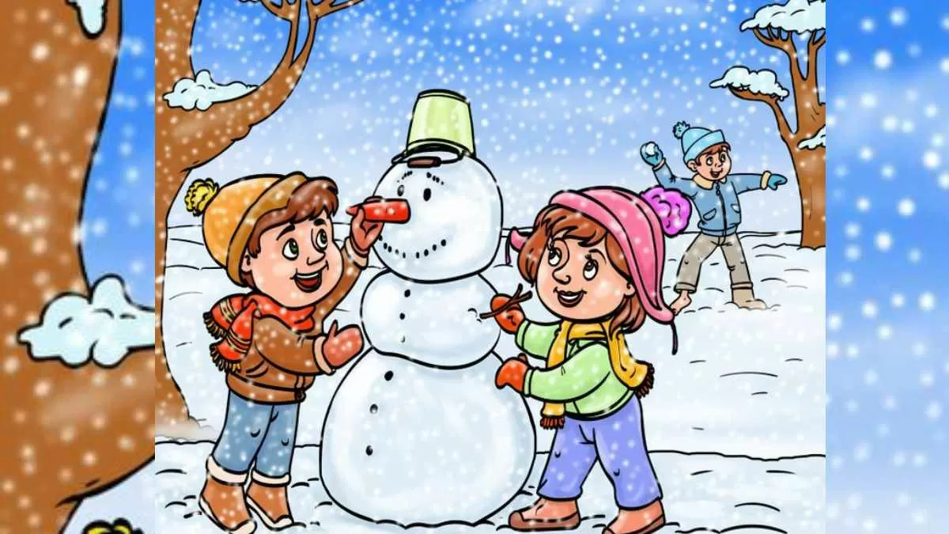

<https://www.jagranjosh.com/general-knowledge/brain-teaser-iq-test-spot-mistake-in-picture-where-kids-are-playing-in-snow-1671105947-1>

**Brain Teaser IQ Test:**If you enjoy solving fun games and puzzles, then this brain teaser is for you! Brain teasers allow you to use the creative side of your mind and make your brain works in a different. This kind of brain puzzle makes a simple riddle more interesting by adding a fun element to it. For arriving at the answer, you need to think outside the box and analyze the puzzle a little differently. So, we have come up with an interesting brain teaser where you have to spot the mistake hidden inside the Picture where kids are playing in the snow.

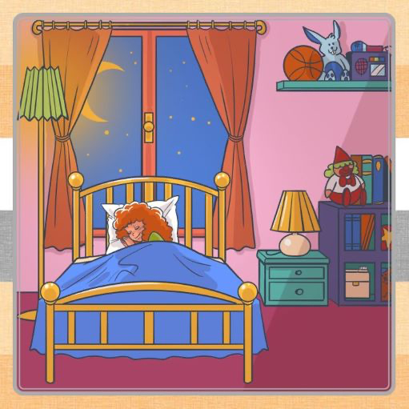

<https://www.jagranjosh.com/general-knowledge/optical-illusion-iq-test-spot-toothbrush-hidden-inside-bedroom-1671013352-1>

**Optical Illusion for IQ Test:**An optical illusion is a mind-bending, deeply fascinating, shape-shifting image of an object or drawing, or people that challenge the brain’s way of perceiving things. You must have seen many types ofoptical illusions like physical, physiological, and cognitive illusions. Studies reveal that optical illusions are also a part of the field of psychoanalysis that throws light on how you perceive things. A normal brain a human can look at things or images differently forming a different perception from each angle.  One such clever illustration can be seen in the image where a Toothbrush is hiding somewhere inside the Bedroom picture.

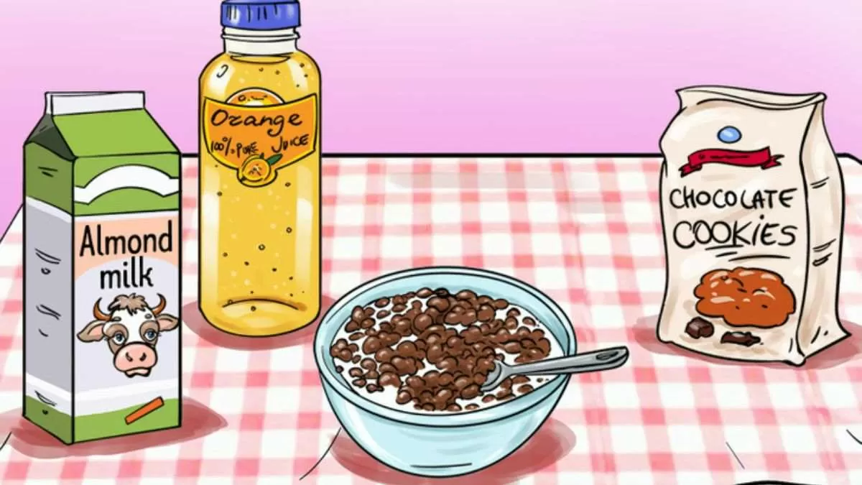

<https://www.jagranjosh.com/general-knowledge/brain-teaser-iq-test-spot-mistake-in-breakfast-table-1671017393-1>

**Brain Teaser for IQ Test:**If you enjoy solving fun quiz and puzzles, then this brain teaser is for you! Brain teasers allow you to use your analytical side and make your brain works in a different way. Such brain quizzes make a simple a puzzle more interesting by adding a fun task to it. For coming onto the solution, you need to think out of the box and analyze the problem little differently. So, we have come up with an interesting brain teaser where you have to spot the mistake hidden inside the Breakfast Table Picture.

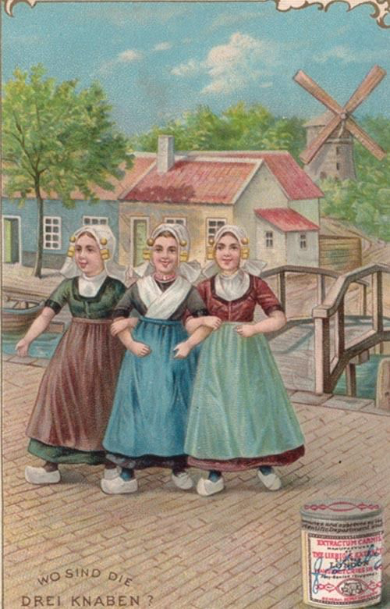

<https://www.jagranjosh.com/general-knowledge/optical-illusions-iq-test-spot-girls-three-hidden-lovers-inside-picture-1671102351-1>

**Optical Illusion IQ Test:**An optical illusion is a mind-bending illustration of an object or a drawing or a picture that has different appearances and can be perceived differently. There are many types of optical illusions like physical, physiological, and cognitive illusions. Many optical illusion images can reveal hidden aspects of our personality and our deepest desires based on what we see. These are also a part of the field of psychoanalysis as they throw some light on your intelligence level.  One such fine illustration can be seen in an old optical illusion painting of three girls and their hidden lovers.



<https://www.jagranjosh.com/general-knowledge/brain-teaser-iq-test-only-3-can-find-what-is-wrong-with-this-ice-skating-picture-in-6-seconds-1671094673-1>